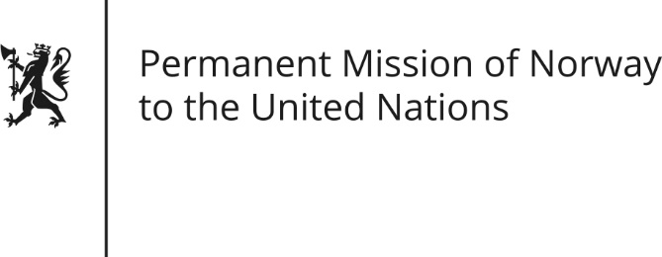

STATEMENT

Universal Periodic Review of Trinidad and Tobago, 10 May 2016
Norwegian Statement by Marit Aspaas
Check against delivery
Mr. President,

Norway would like to commend Trinidad and Tobago for its commitment to follow up the recommendations accepted in the previous UPR-cycle. Norway notes with satisfaction the important gains that have been made regarding legislative reforms relating to violence against women. However, high levels of gender-based violence is a concern. Norway is also worried about continued stigma and discrimination against LGBTI-persons, as well as people living with HIV. Furthermore, we note with concern that Trinidad and Tobago has failed to outlaw child marriage. Norway would therefore like to take this opportunity to provide the following recommendations to Trinidad and Tobago:

- Norway recommends that Trinidad and Tobago continues its significant efforts to promote gender equality, in particular the implementation of the Draft National Gender Policy as well as the proper enforcement of the existing legal frameworks.

- Norway recommends building state capacity to develop policy and programmatic responses to address the needs of people living with HIV.

- Norway recommends that steps are taken to combat discrimination of LGBTI people in legislation and practice, including decriminalisation of sexual activities between consenting adults of the same sex.

- Norway recommends to set the universal minimum age for marriage to 18 years, in line with the Civil Marriage Law. Moreover we recommend to repeal the legislation that exempts spouses of minors from prosecution for sexual offences against their spouse.

- Lastly, Norway recommends abolishment of the death penalty.
Thank you.

